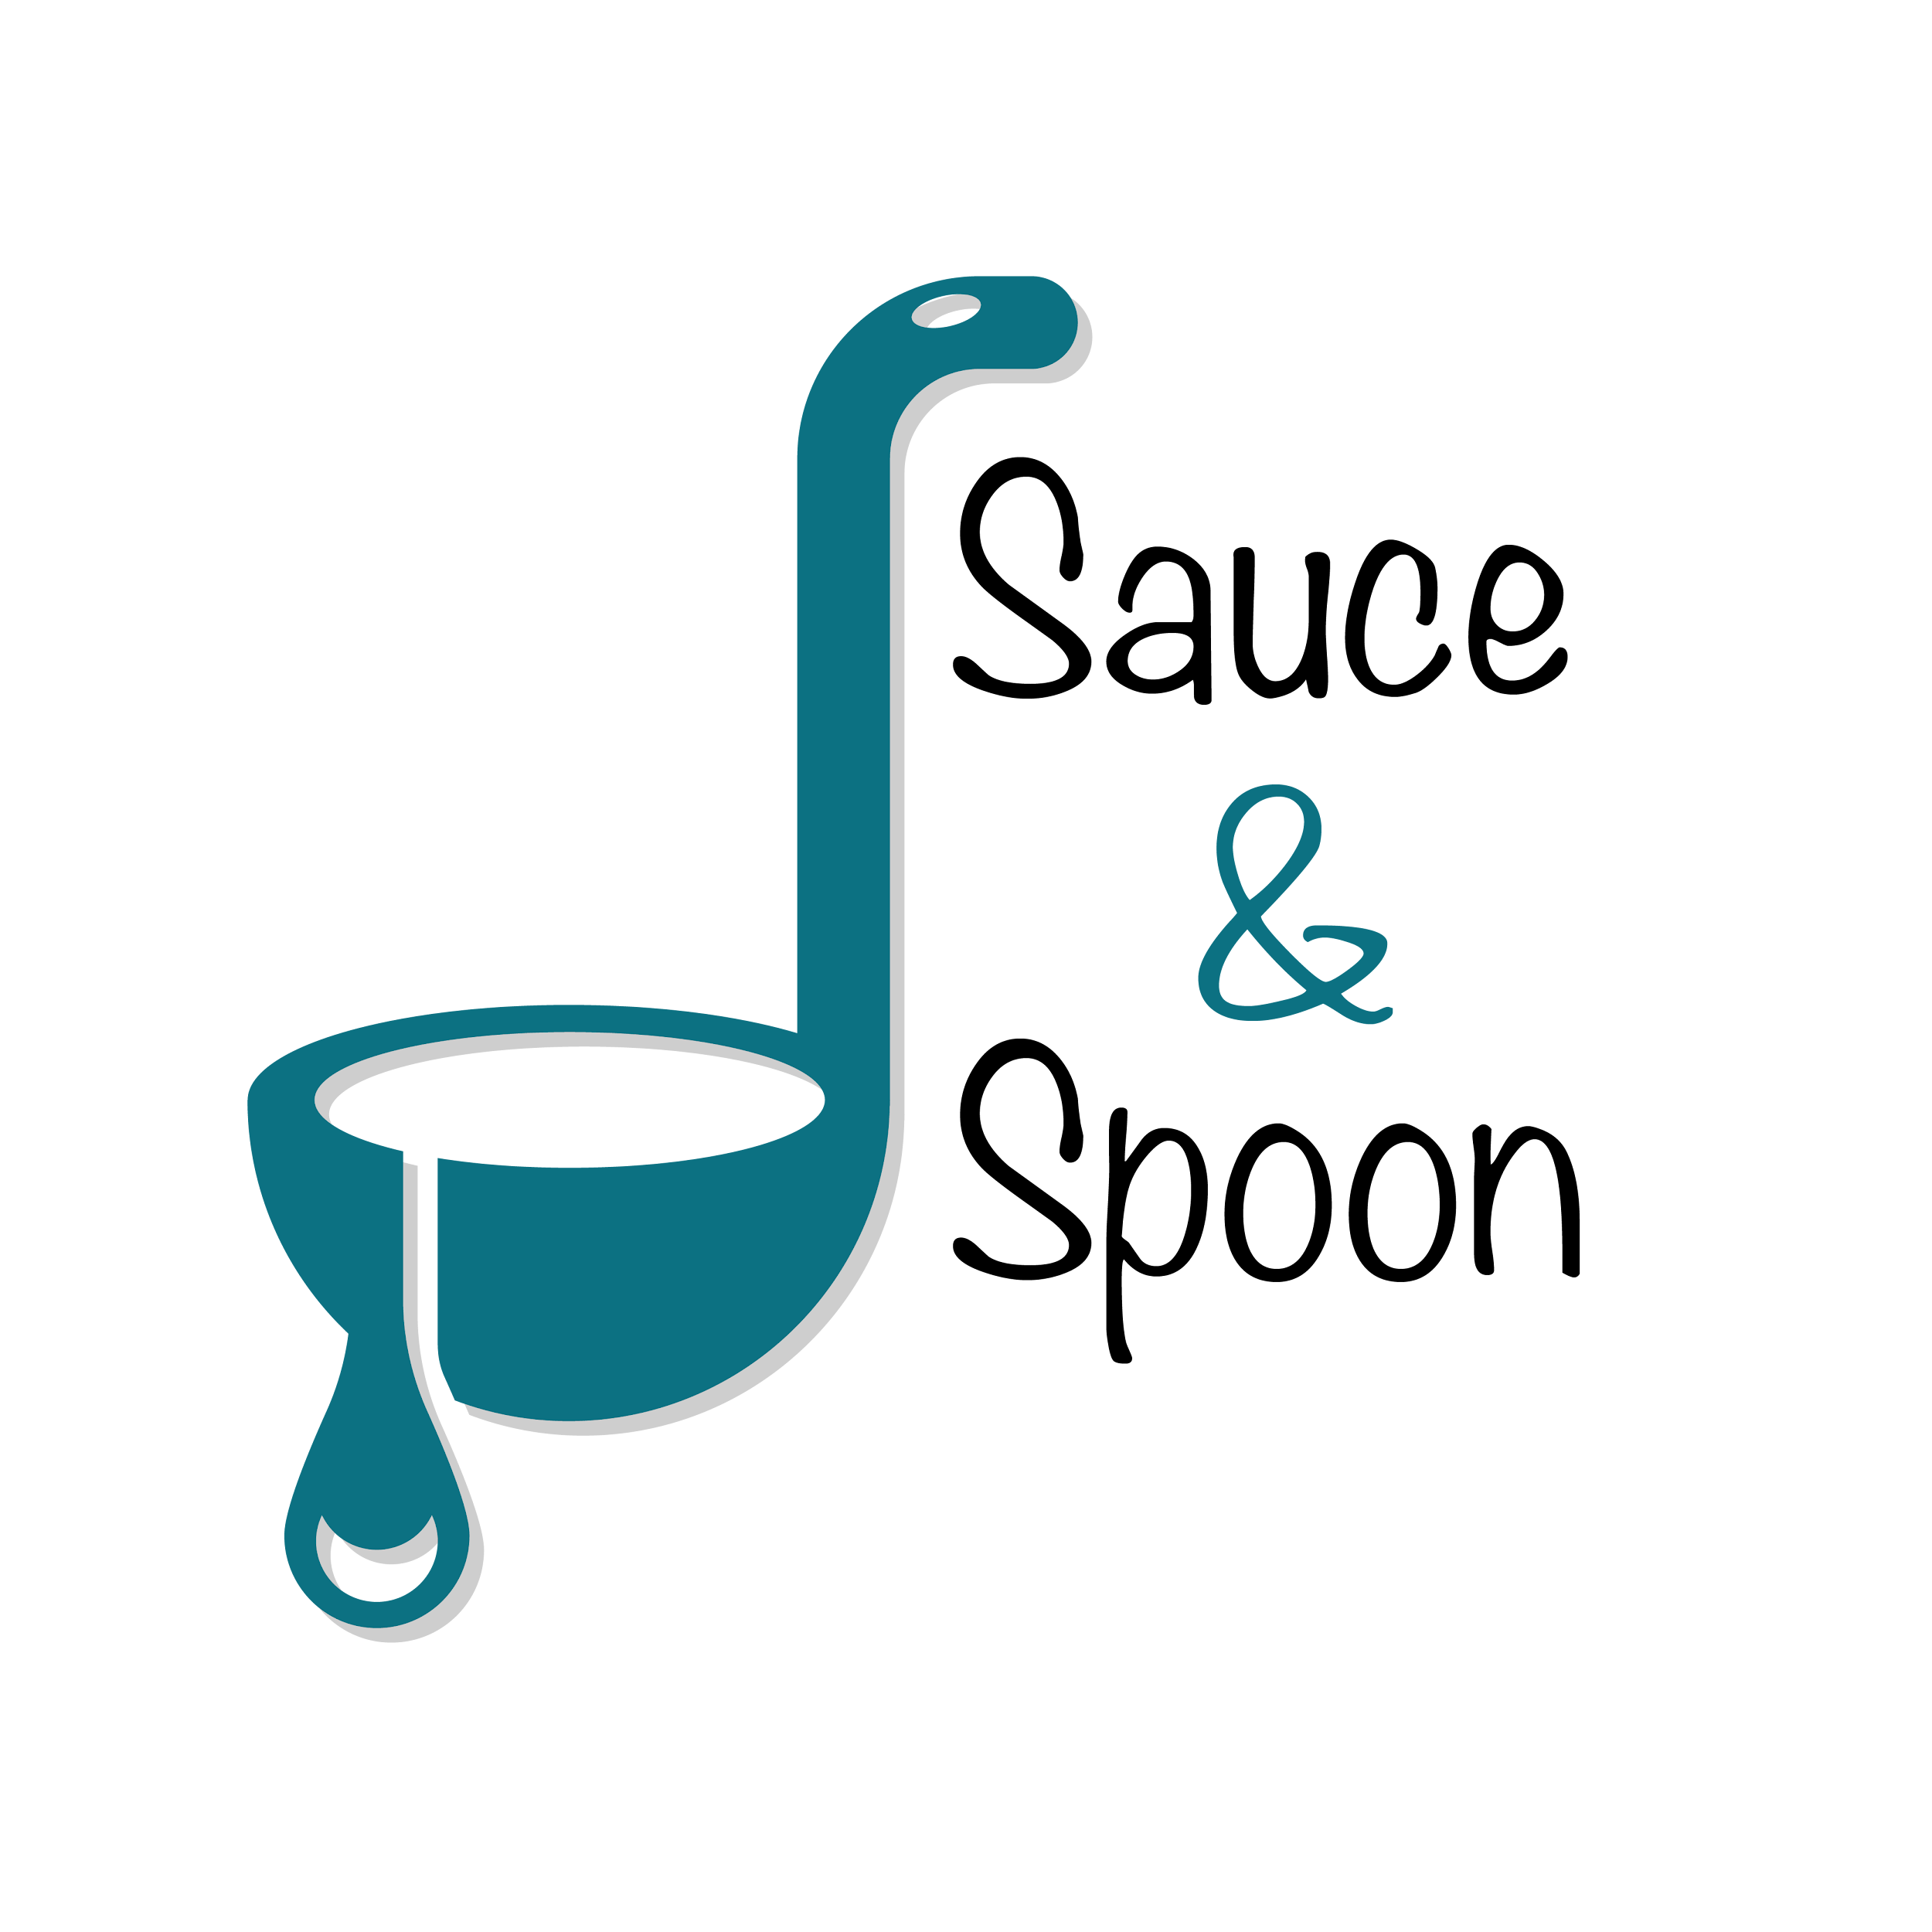

Project Charter: Tabletop menu tablets

DATE: 18/04/2025

| **Project Summary** |
| --- |
| This is a pilot project to test out the launch of table top menu tablets in the bar area of Sauce & Spoon restaurant aiming to meet its annual growth and expansion goals. |

| **Project Goals** |
| --- |
| * Reducing average table turn time from 80 mins to 50 mins by EOY * Increase average guest count by 10% * Cut down food waste by 25% EOY * Increase appetizer sales by 10% for North and 20% for downtown restaurants * Decrease customer checkout time by 10% on average in the first six weeks after implementation * 95% customer satisfaction in the pilot phase |

| **Deliverables** |
| --- |
| * Table top tablets in the bar area of North and Downtown restaurants * Ability place an order and change the order requirements after placing the order solely by the customer * Ability to capture clear data points of customer order for future analysis * Promotion of specific menu items as add-ons, displaying coupons for those items * Training of management, FOH staff, and BOH staff * Hiring of additional staff (e.g., expediter, BOH staff, IT support staff) per location, as necessary * Integration with current Point of Sale (POS) and Host systems |

| **Scope and Exclusion** |
| --- |
| **In-Scope:**   * Reducing the average guest wait time and table turn time * Hiring additional staff * Post dining survey implementation   **Out-of-Scope:**   * Adjusting the policy on order returns * Reducing employee turnover |

| **Benefits & Costs** |
| --- |
| **Benefits:**   * Potential to speed up service and increase sales * Tablets will provide the restaurant clear data points on customer ordering and integrated POS * Reduce food wastage   **Costs:**   * Training and material fees - $10000 * Hardware and software implementations across locations - $30000 * Maintenance - $5000 * Updated website and menu design fee - $5000 * Other customization fees - $550 |

| **Appendix:** |
| --- |
|  |